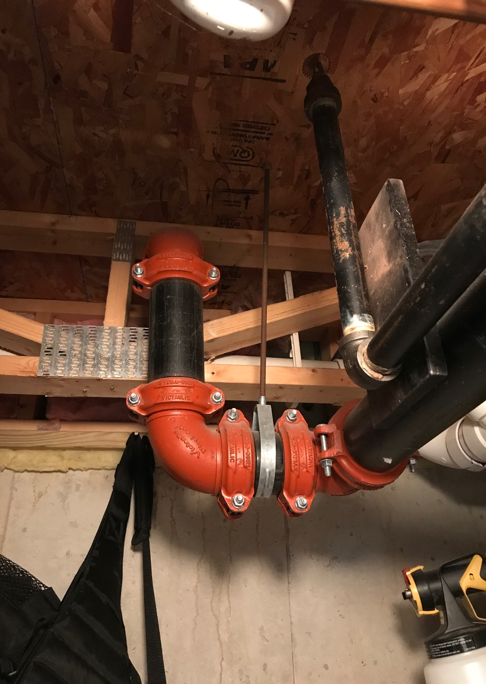It is important for homeowners to know where and what certain portions of the sprinkler system they have control over within the unit. All units have a main pipe feeding water to the unit sprinkler system from the Sprinkler Room in the basement. This pipe can be identified as the large black pipe with red fittings that goes through the walls between units. Here is an image of what that may look like, but keep in mind every unit may be a little different.

This large black pipe should run along the length of the basement and somewhere along it there should be a fitting with a branch off to a control box via a smaller pipe. Something like the below image.

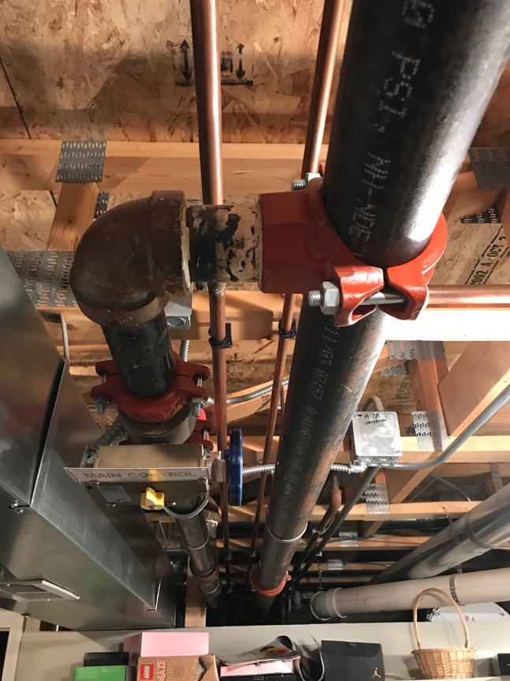

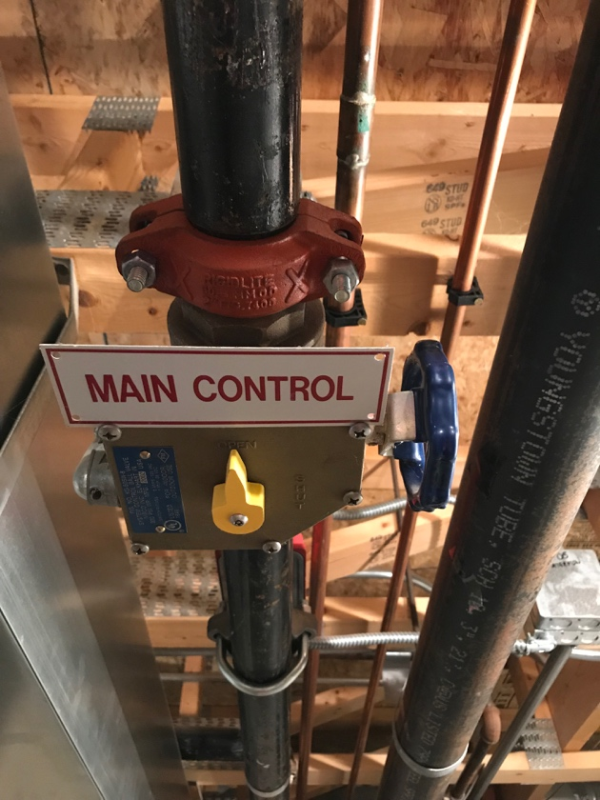This branch off is the main feed for the entire sprinkler system in the unit. There should be a control box off of that initial branch. The box should look like the below.

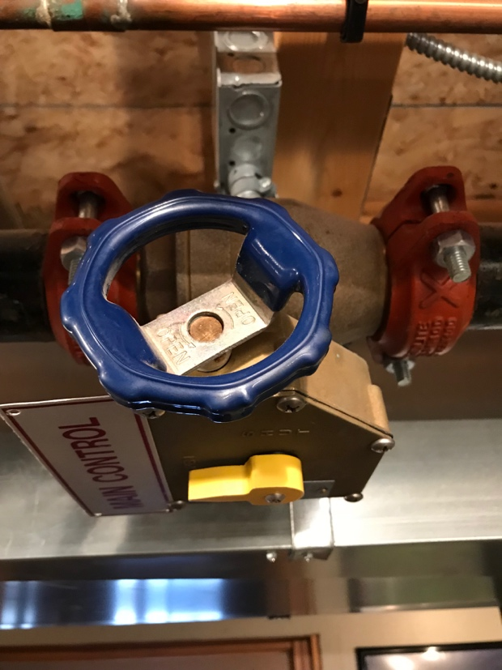There will be a control knob on it and an indicator that shows OPEN and CLOSE directions. In operating mode it should be OPEN.

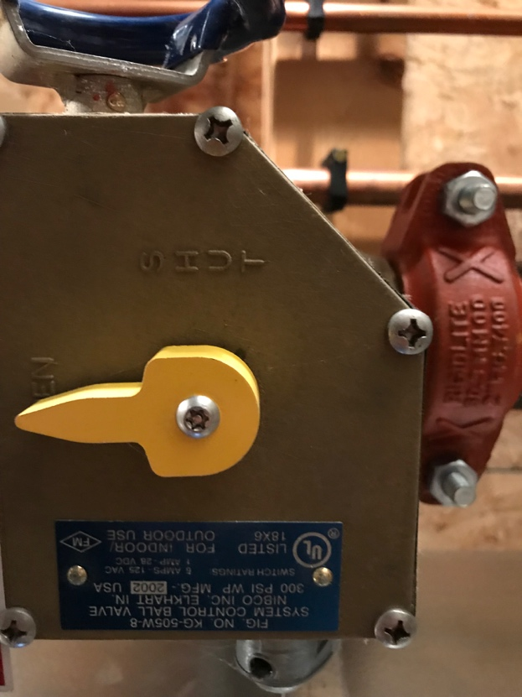The box is wired to the fire panel in the Sprinkler Room and the panel tracks the OPEN/SHUT conditions. In SHUT situations the fire panel is triggered and fire department is notified.

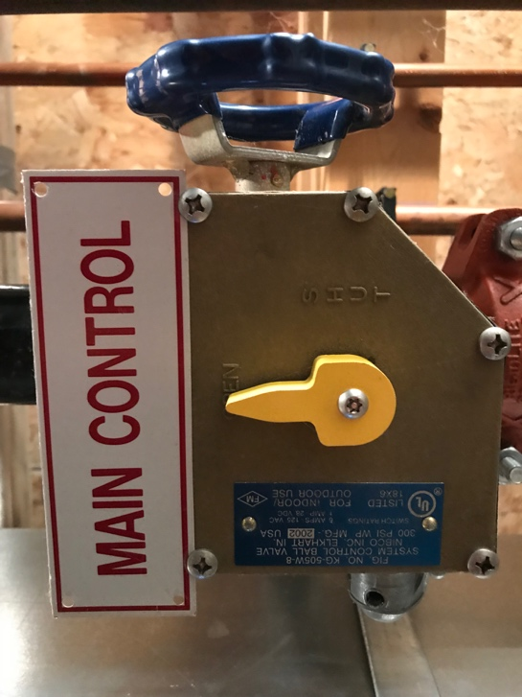In an emergency such as a broken sprinkler head or broken pipe where water is running into the unit, it is perfectly acceptable to CLOSE this valve immediately and wait further direction.